Assignment 4:

Determine Memory OLTP

Firstly, we created a database for this, in that we created 3 tables such that 1 is normal table and other 2 tables are memory optimized with Schema only and Schema and data respectively as shown below snip

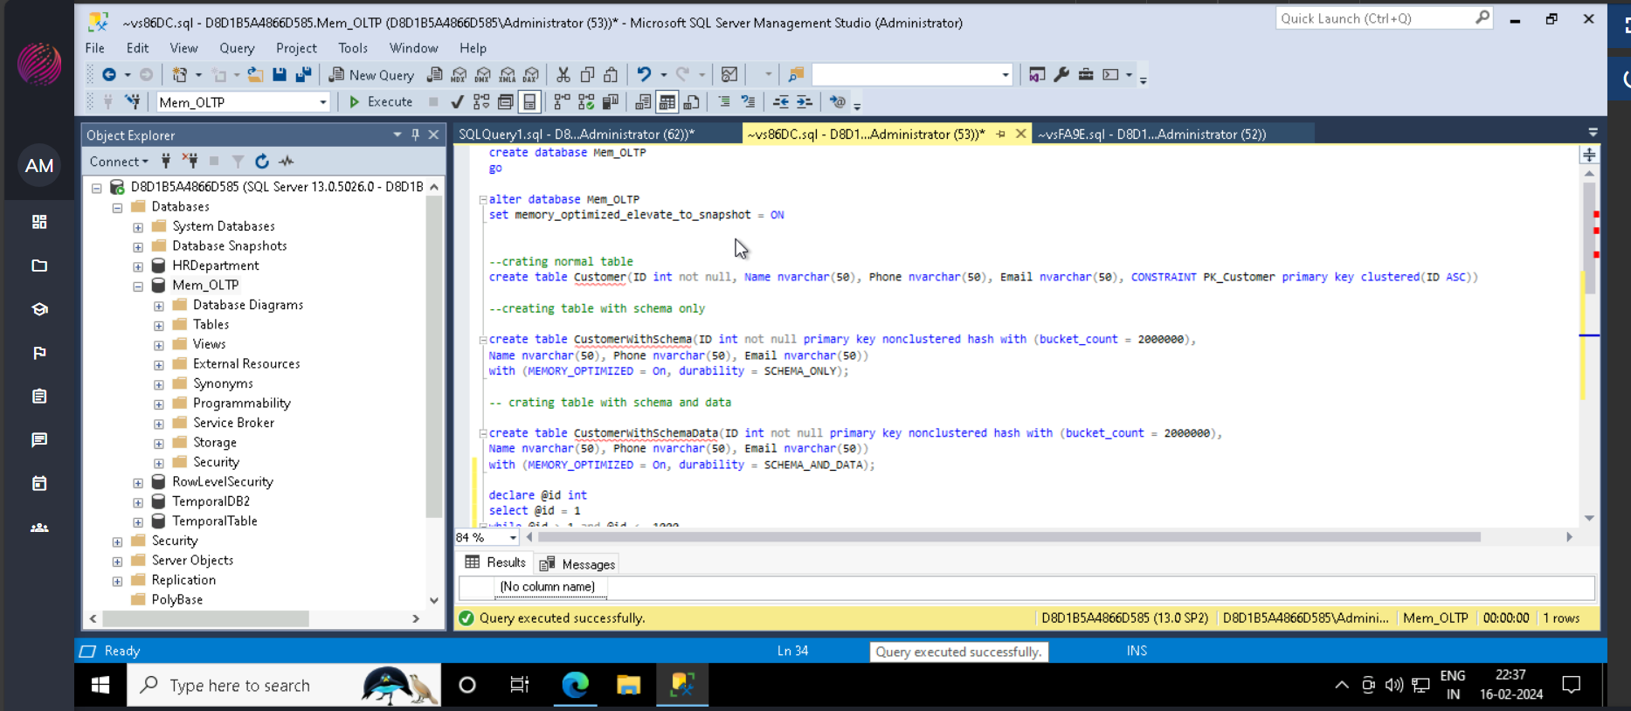

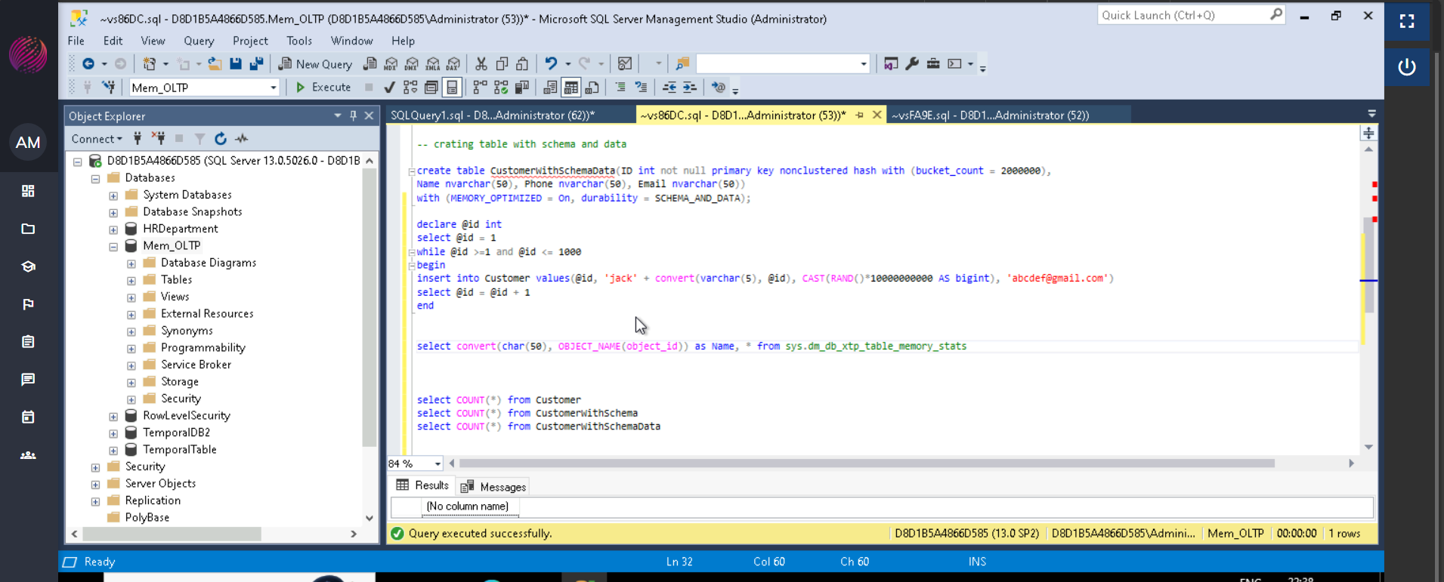

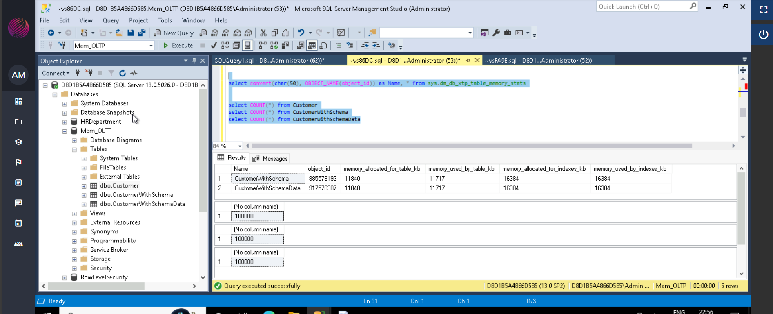

From above we can see that table Customer is not memory optimized table, if there are multiple tables, we can determine tables without memory optimized as shown below,

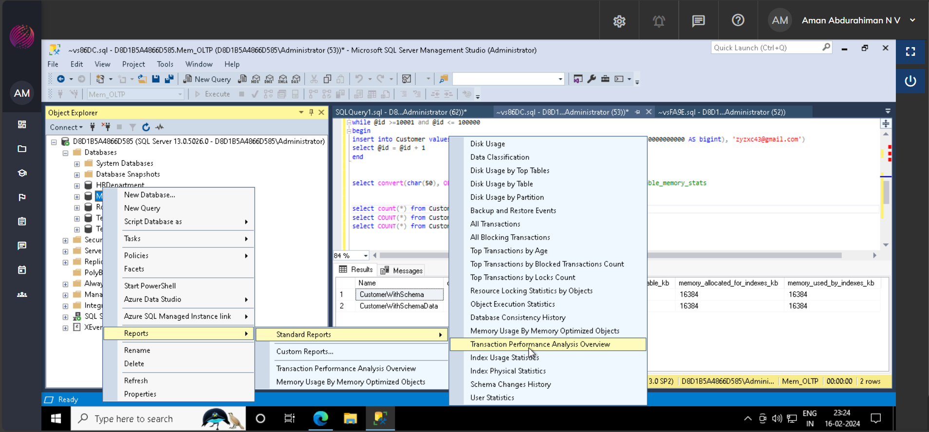

From this report, we click on Table analysis we can determine the tables present in graph shown at High gain area of graph shown non memory optimized tables

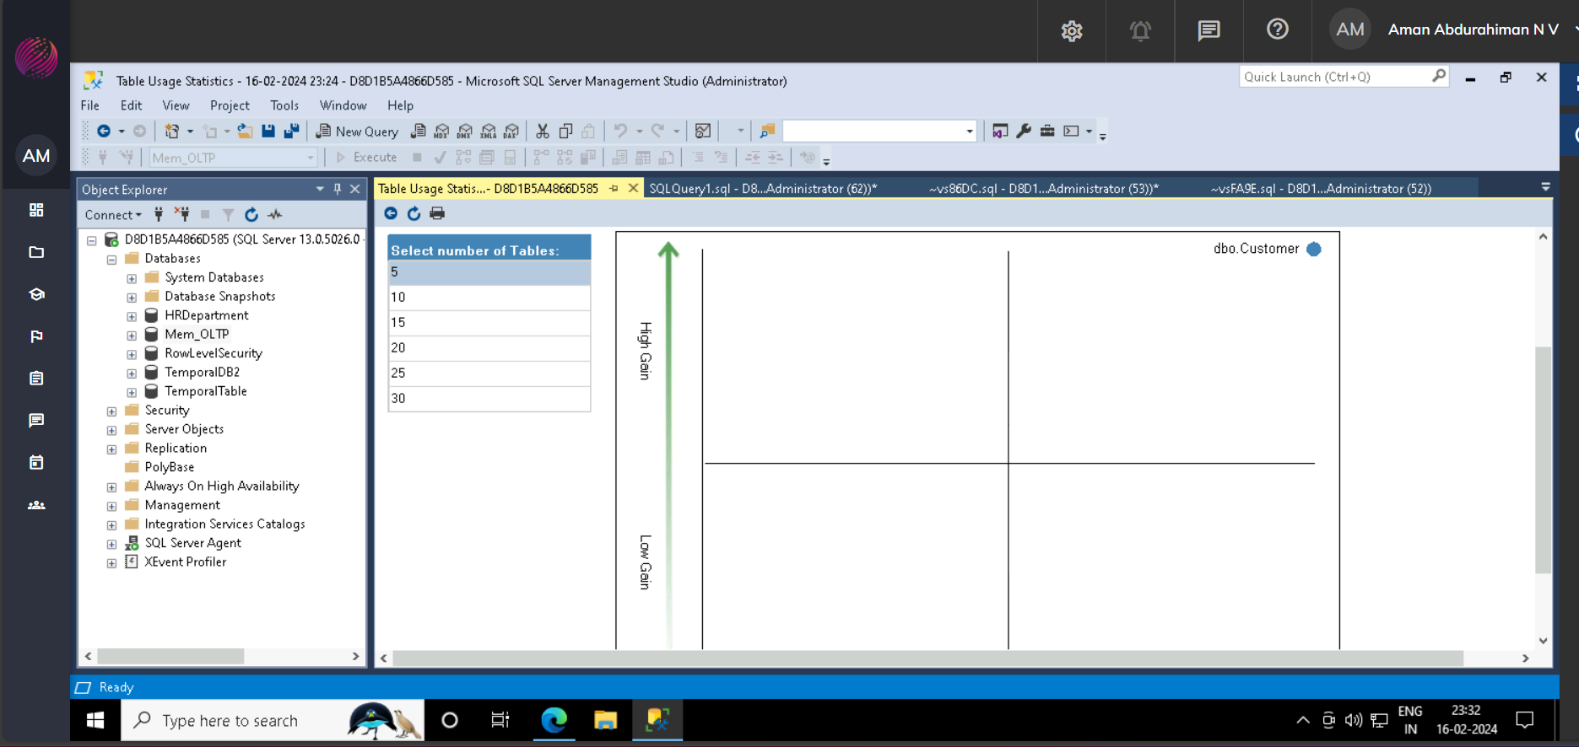

We can convert them to Memory optimized table as shown below,

Right click Table --> Memory Optimized Advisor

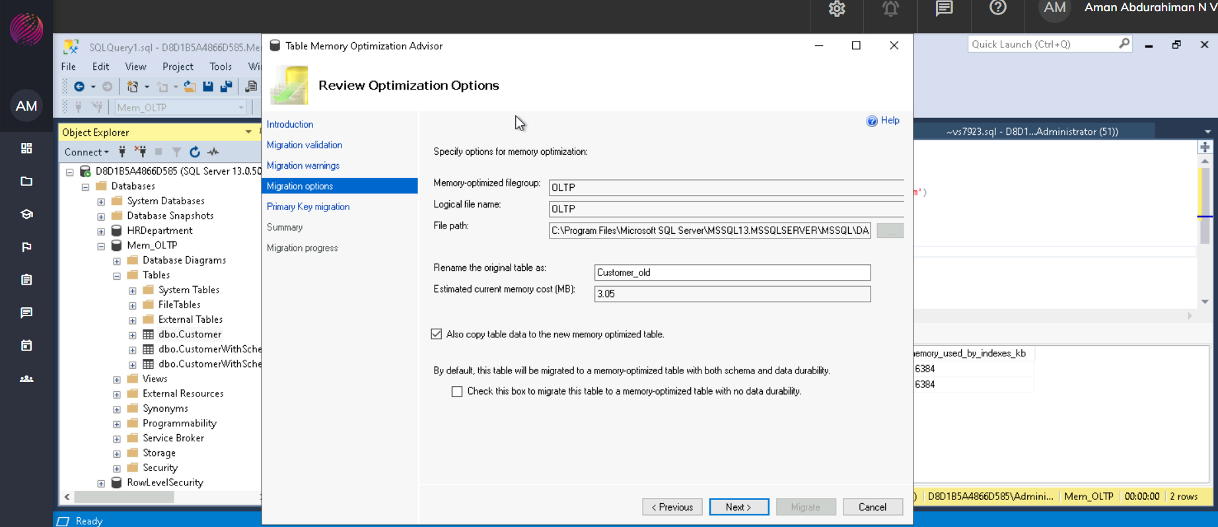

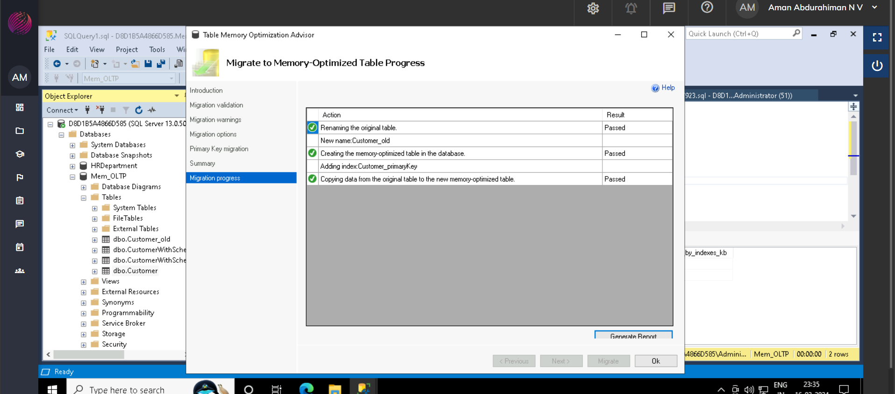

Now we could see current/old table table renamed to “Customer_old” and new table with Memory Optimized is created with original table name i.e “Customer”.

As shown below.

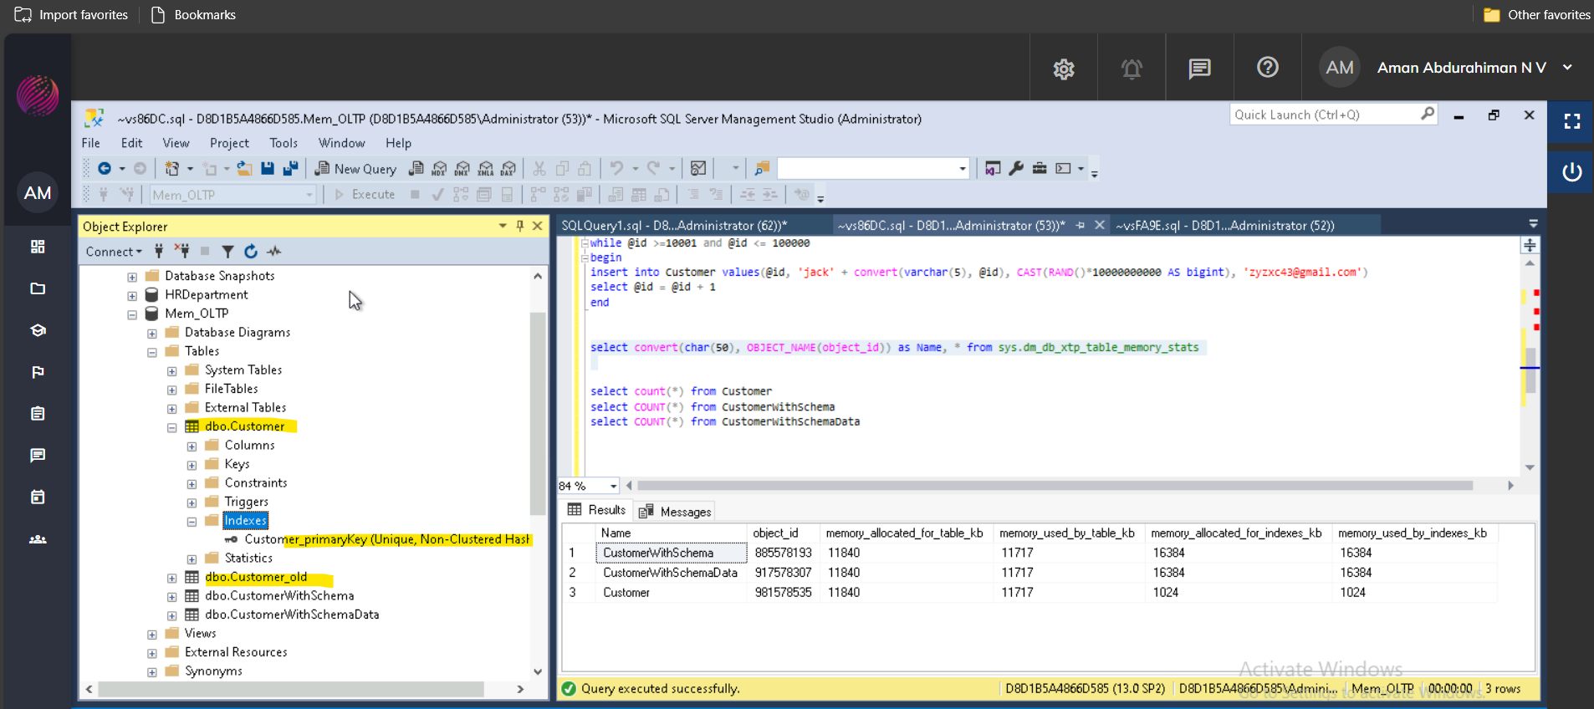

Setting up Polybase account in SQL server

Below are the steps to install Polybase in SQL server,

1. Open SQL server installation center and click 1st option as shown below.

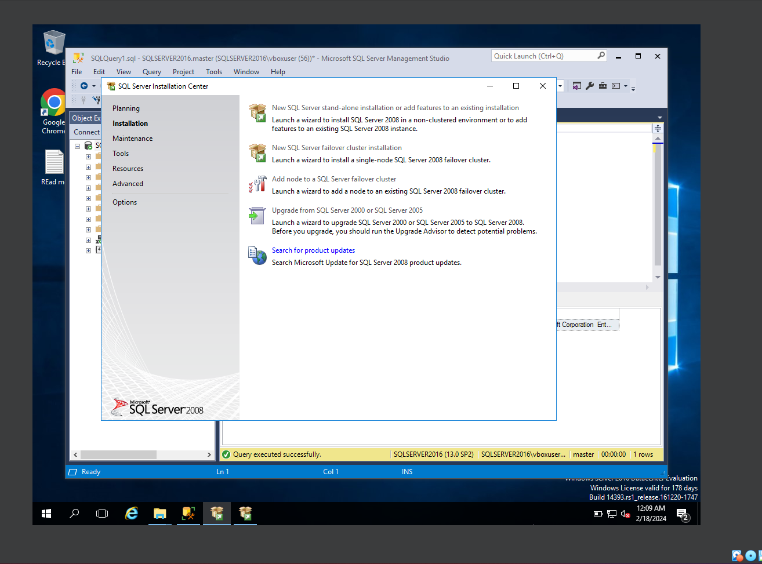

Choose add feature in existing SQL server and click Next

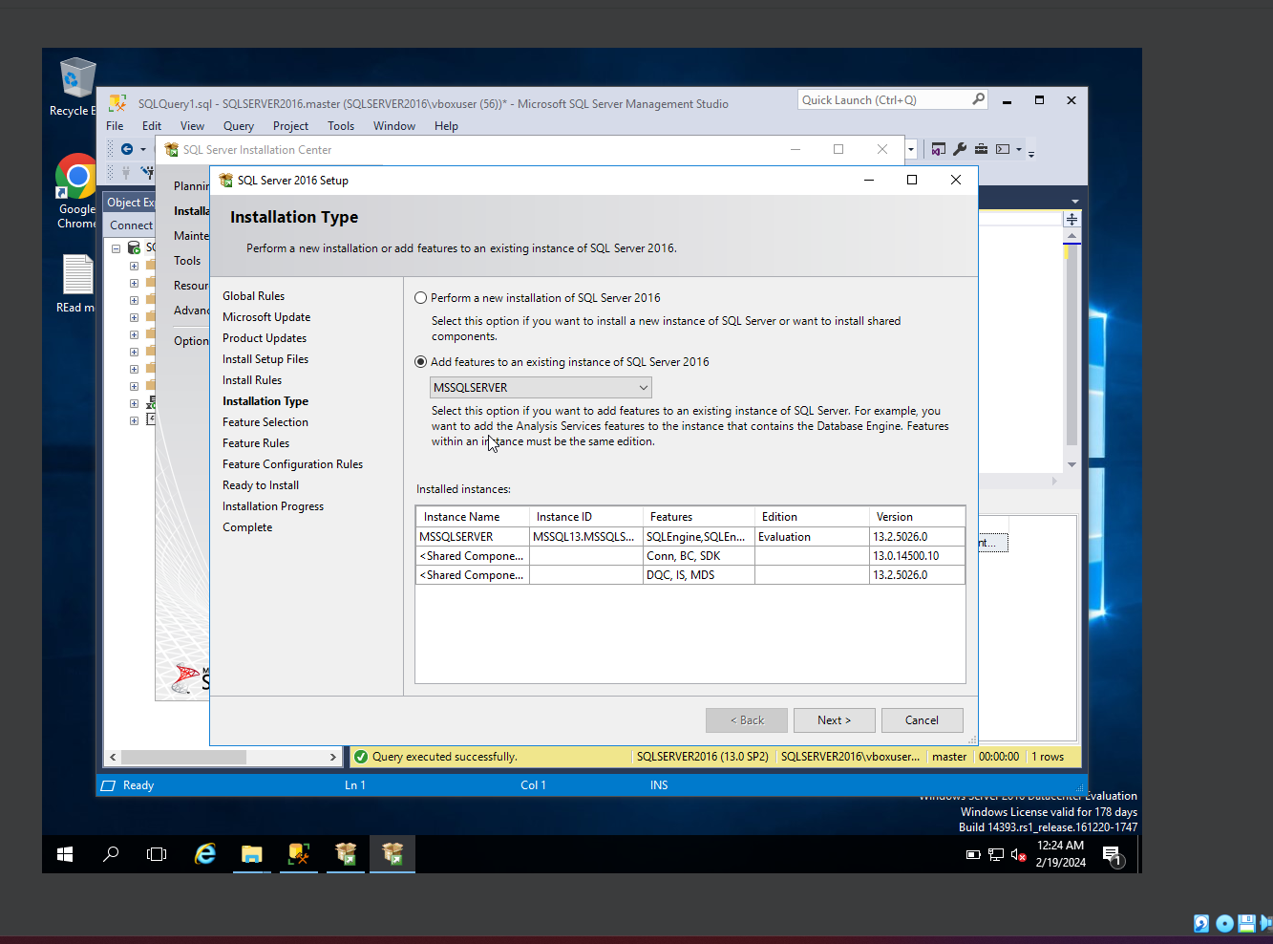

Now, click on Polybase in Features option as shown below

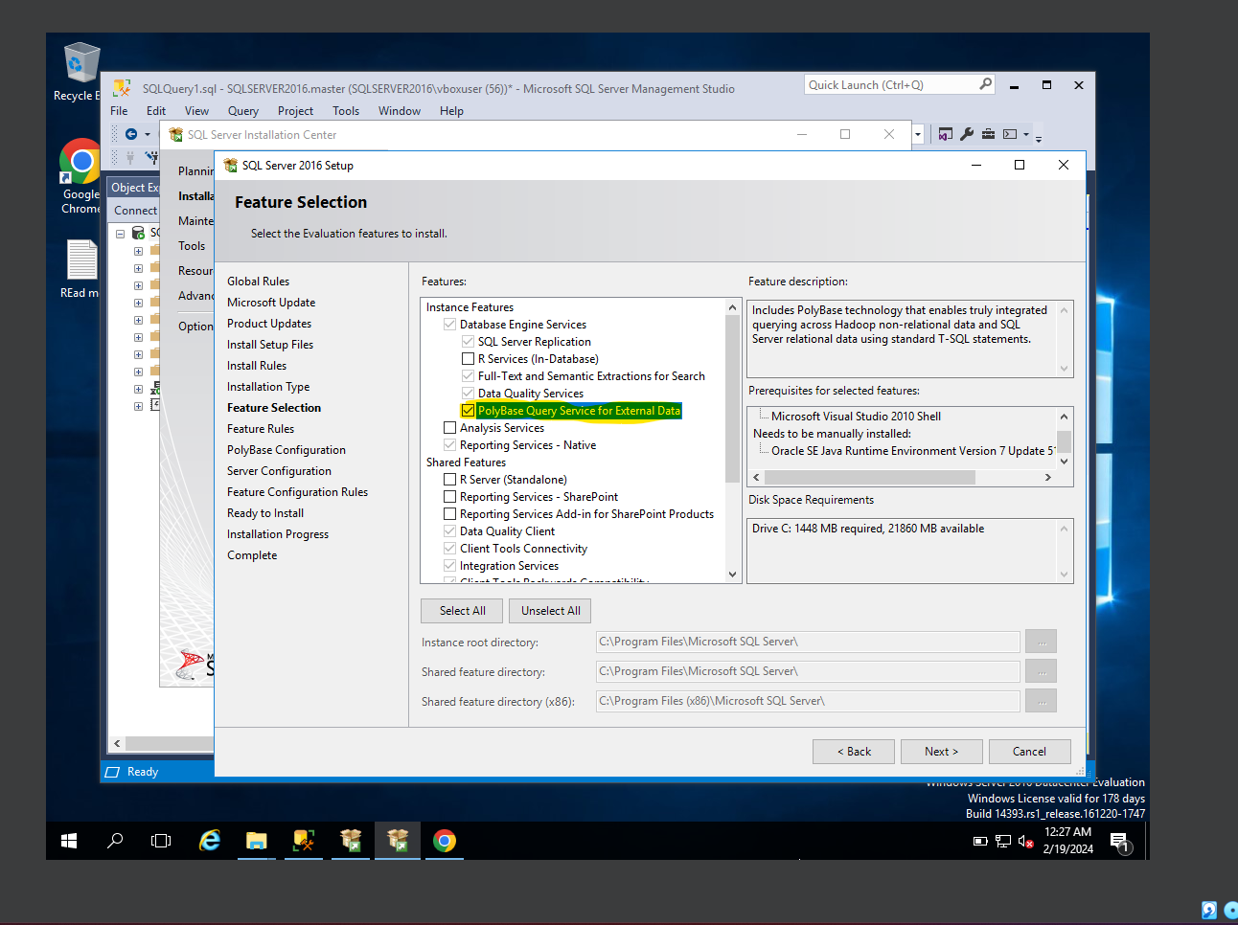

Polybase has been setuped in SQL server, as shown in below snip

